Writing for the web
This document should be read in conjunction with the Style Guide: https://intranet.uhi.ac.uk/marketing-and-communications/guidelines
Introduction
Usability.gov states:
“When writing for the web, using plain language allows users to find what they need, understand what they have found, and then use it to meet their needs. It should also be actionable, findable, and shareable.”
This document will provide some basic information and links to references to help understand how you can best meet the needs of your audiences when writing content which will appear on your website.
Devices
It is important to remember that people reading your content could be doing so on any one of a number of devices – computers, mobile phones, kindles, televisions, tablets, etc. Our web design is intended to display on a wide array of devices – content plays its part in this. If you’ve added some content to a page from a computer, you can quickly check how it might appear on different screens by resizing your browser window. The university homepage shows a fully-designed example of this:
Wider / Desktop Narrower / Tablet Narrow / Phone
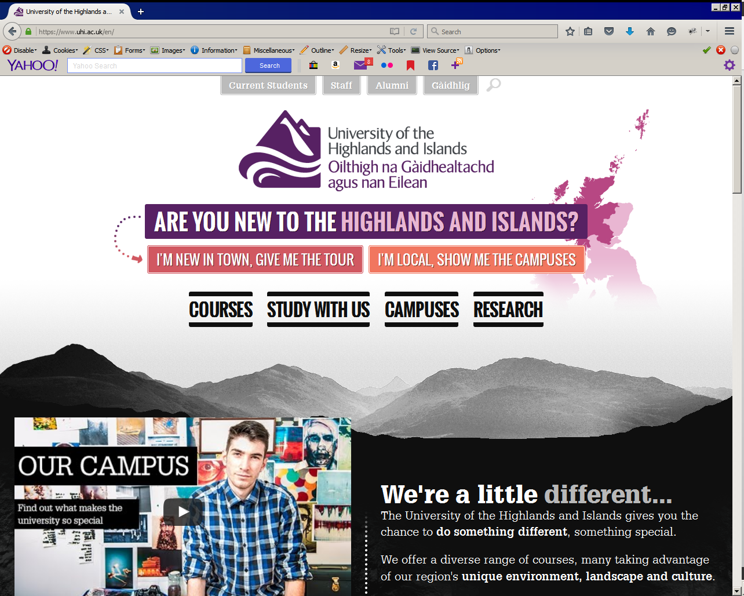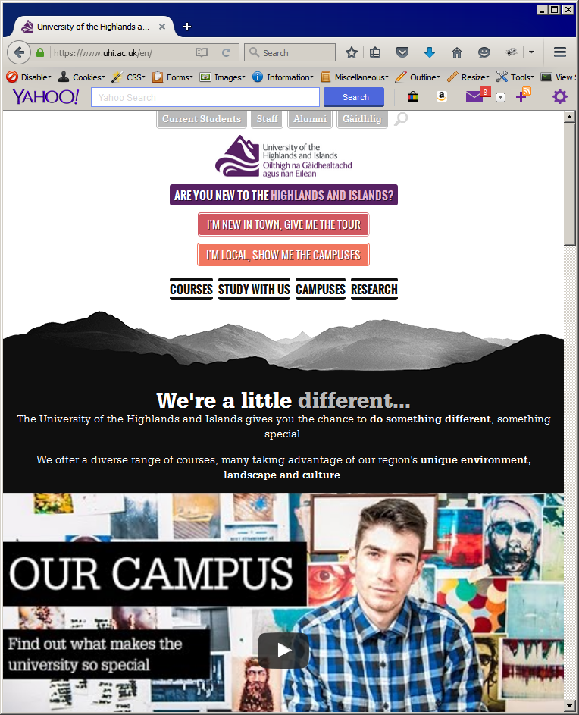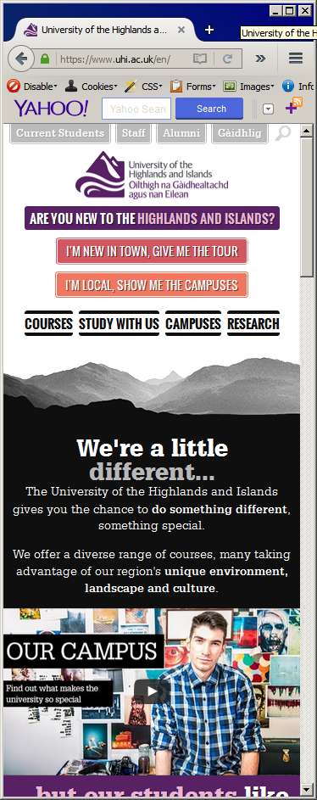

Formatting Text
The university’s Content Management System (CMS) and web design are intended to provide legible text with a good contrast. There should be no need to significantly restyle content which you submit e.g. changing font colour, style, size, layout, etc. Where you wish to add emphasis or chunk content to make it easier to read, then use the options provided by the CMS – headings, bold, links, bullets, etc.
If you find yourself repeatedly using a tool to get your desired effect or if you seem to be ‘fighting’ against the CMS then contact webteam@uhi.ac.uk to discuss the user need(s) you are trying to meet in case it is possible to make a site-wide amendment to help.
Creating links
Links are a great way to break up your content or to help your user find content in other locations. The actual text which you choose to link is a key part of this. The link text should be meaningful. For example, instead of linking in this way:
To download our policy document, click here.
You should try:
You can download our policy document.
Images
Do not use images to convey textual information. An image can contain a heading or limited information, but only if it also has an ‘alt’ tag. They should never contain longer strings of text. An ‘alt’ tag is a piece of text information which describes what is in the image; if text is part of an image, then that tag should convey the meaning of that text. The tag can then be read by other technologies such as screen readers which can help users with visual impairments understand the content of a web page.
By using the ‘description’ field for an image in the CMS, the CMS will automatically add the ‘alt’ tag.
Maintaining content
Good content is current and accurate. If you’re adding content which may change over time such as exam dates, term times, policies, etc. then it is important that this content is reviewed at an appropriate interval.
The CMS allows you to set content to ‘expire’. This means that if you know content is time-sensitive when you add it, you can set the CMS to remove it from the site at a specific point in time. This is commonly used for Events content but can be used for other content types where appropriate.
Training and consultancy
If you would like to explore writing for the web further, please get in touch with webteam@uhi.ac.uk to arrange a chat, presentation or training session.

References
- 8 Simple Writing for the web guidelines - http://www.webcredible.com/blog/content-usability-writing-web/
- How users read - https://www.nngroup.com/articles/how-little-do-users-read/
- BBC Writing for the web (journalism) - http://www.bbc.co.uk/academy/journalism/article/art20130702112133610
- 9 tips - http://www.enchantingmarketing.com/writing-for-the-web-vs-print/
- Web writing vs marketing or academic writing - https://boagworld.com/content-strategy/writing-for-the-web-is-hard/
- Lynda.com course - http://www.lynda.com/Web-Content-Strategy-tutorials/Writing-Web/180104-2.html (From https://www.uhi.ac.uk/en/staff/ “To access the service, visit lynda.com, select "log in" and enter www.uhi.ac.uk in the "Log in through your organization or school" box. On the next screen, enter your university user name and password.”)
- Example of front-loading and other guidelines - http://readwrite.com/2012/03/16/best_practices_for_writing_for_online_readers

http://www.usability.gov/how-to-and-tools/methods/writing-for-the-web.html
Chunking makes your content more scannable (See reference on how users read) by breaking it into manageable sections.

