Visits – 93,171 |  |  | 43%  45%  4.7%  35.5%  3.06s | from Google  Direct  from outwith UK  Mobile (of which 51.8% Apple)  Average page load time
vs Last Month  vs Last Year | ▼ 25.7%  ▲6.7%
Courses by month (previous month) |  |  |  | Courses by year-to-date
- BSc Nursing (-)  - BA Hons Childhood Practice (-)  - PGDE Primary Teaching (-)  - MBA Business Admin Executive (5)  - MSc Applied Data Science (4)  - BSc Hons Psychology (7)  - BA Hons Child and Youth Studies (6)  - MSc Advanced Nurse Practitioner (17)  - MSc Psychology Conversion (-)  - HNC Accounting (8) |  |  |  | - BSc Nursing  - PGDE Primary Teaching  - BA Hons Childhood Practice  - BSc Hons Psychology  - MSc Applied Data Science  - BA Hons Child and Youth Studies  - MSc Psychology Conversion  - MBA Business Admin Executive  - HNC Childhood Practice  - MSc Adv. Nurse Practitioner
Applications
Clicks to UCAS 326 (27%) |  |  |  | Internal Applications (Degrees) 1073 (25%) (pageviews)
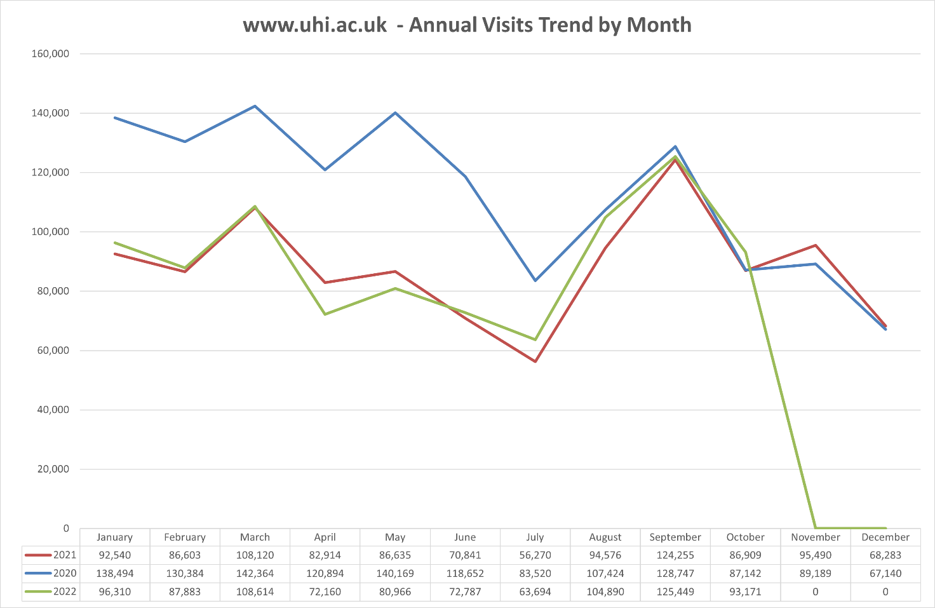
Social Media
Facebook Followers  32,461 -6 |  | Twitter Followers  16,049 -1 |  | YouTube Views  1.149m +3000 | Insta Followers  4,052 +54
Annual Cycle - One Web Partners
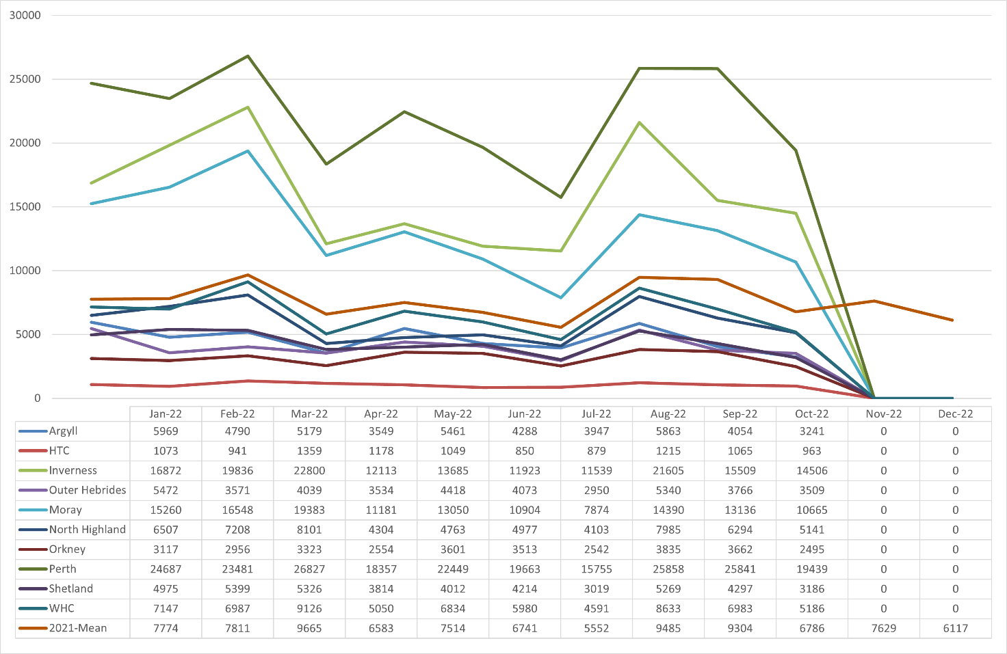
Referrals to www.uhi.ac.uk
From One-Web |  |  |  | From non-One-Web
www.inverness.uhi.ac.uk 1710  www.perth.uhi.ac.uk 1492  www.moray.uhi.ac.uk 1114  www.whc.uhi.ac.uk 509  www.northhighland.uhi.ac.uk 453  www.outerhebrides.uhi.ac.uk 335  www.shetland.uhi.ac.uk 380  www.argyll.uhi.ac.uk 331  www.orkney.uhi.ac.uk 277  www.htc.uhi.ac.uk 143 |  |  |  | sams.ac.uk 126
Campaign Activity
Campaign | Medium | Pageviews | Goal Value
VacancyRSS | eMail | 758 | £4.50
VacancyClickOut | Website | 666 | £8.00
UHIOpenDayClickout | Website | 162 | £5.00
sinfolineoct22 | Social | 155 | £0.00
Marketingofficeroct22 | Social | 129 | £0.00
publicloginpage | WiFi | 68 | £21.00
webmanager22 | Social | 67 | £0.00
nursingandohl13oct22 | Social | 66 | £1.50
discretionaryfundoct22 | Social | 45 | £6.00
WhyMoray | Social | 18 | £1.00

